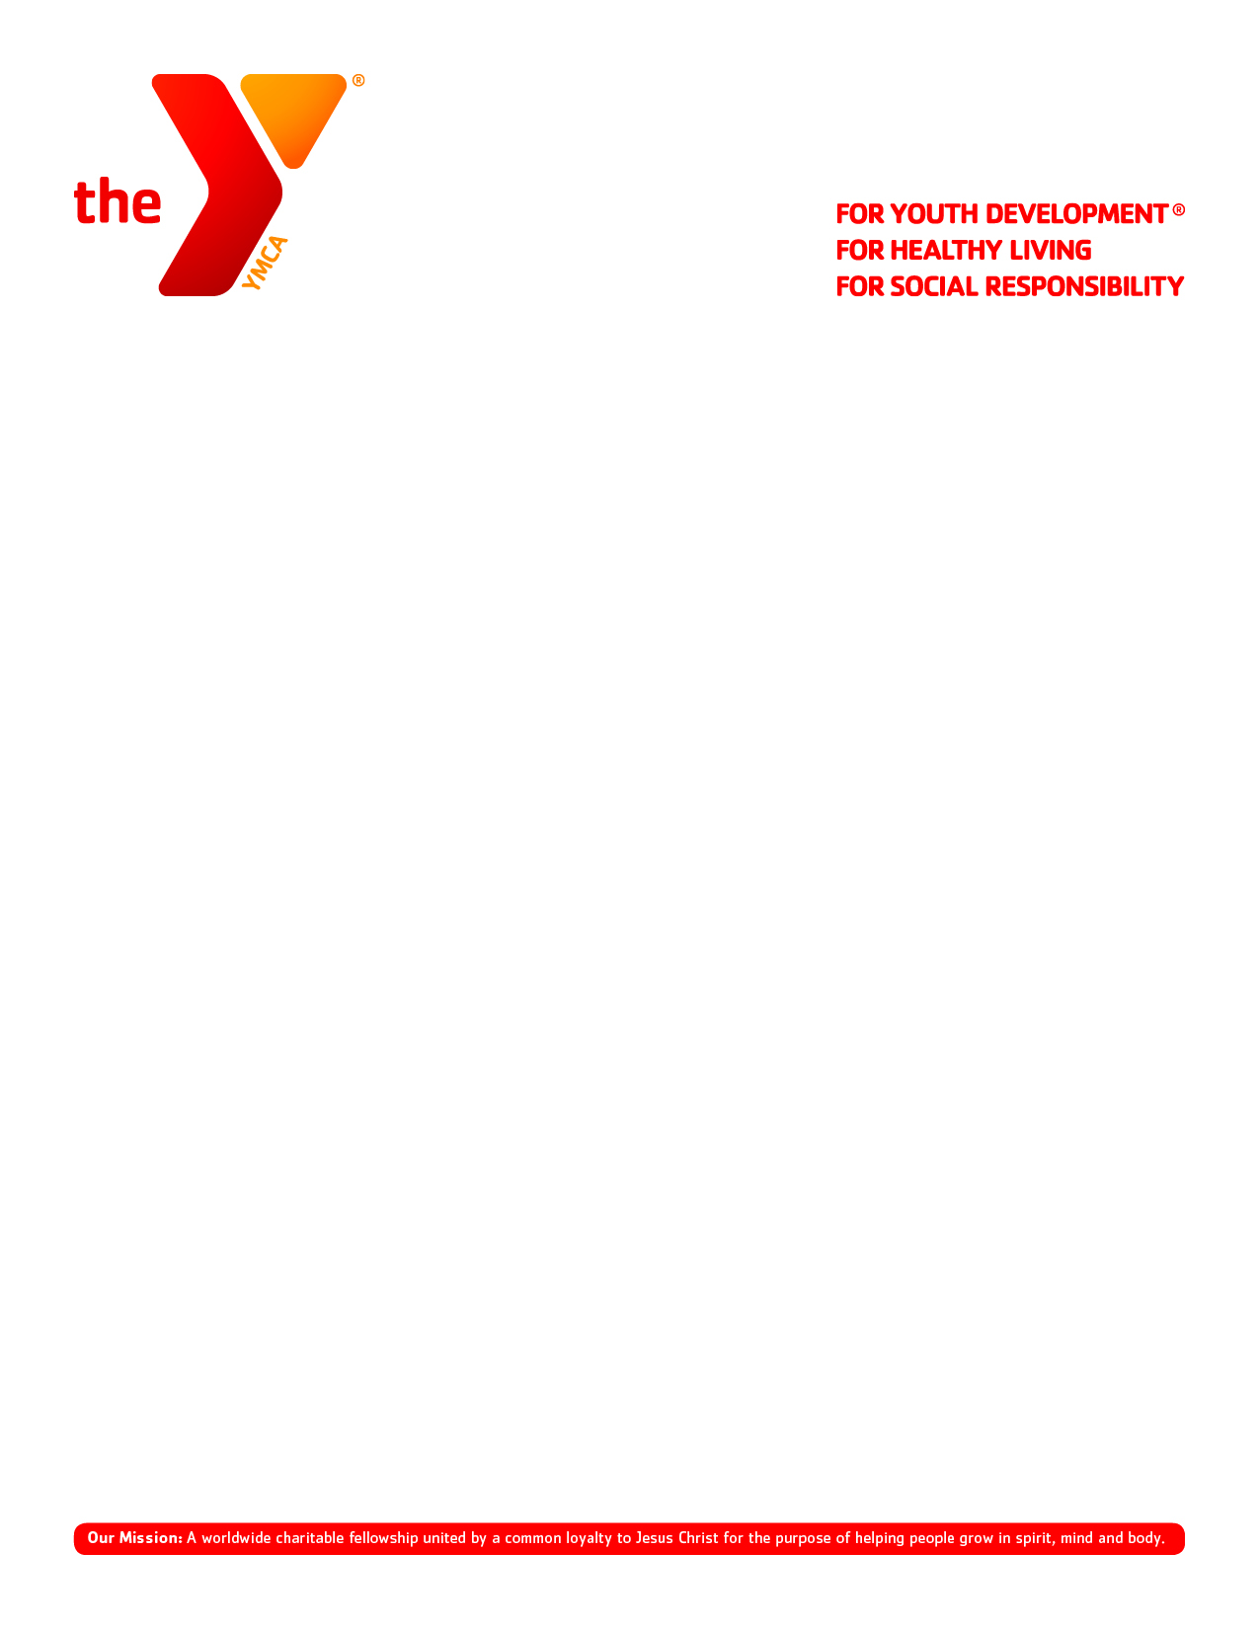

2023 Community Campaign Best Practices

Planning and Targets

- February: Community Campaign details discussed at Leadership Staff Meeting and Executive Director of Annual Giving
- March 3: Community Campaign Toolkit Items in-hand
- March 8: Community Campaign Campaigner Training I (link coming soon!)
- March 15: Community Campaign Campaigner Training II (link coming soon!)
- March 25: 50% of Community Campaign Achieved
- April 1: 75% of Community Campaign
- April 7: 100% of Community Campaign and AGC

Community Campaign Toolkit Items

- Lobby Thermometer
- Community Campaign Campaigner Forms
- Case for Support Documents
- Cause Cards (Learn, Grow and Thrive)
- Program Info Docs (ABC, Full Circle, Spirit Mind Ministry, CCE)
- “I Donated” Stickers
- Members Helping Members T-Shirts
- Recognition Cards
- Group Exercise Instructor Scripts
- Personal Trainer Email Script
- YPLAY/SAS Coloring Pages

Schedule

- March 20 – 26: Strengthening Our Core Campaign
  - Community Renewals
  - Wellness/Group Fitness/Personal Training
  - Membership

- March 27 – April 2: Growing with Our Families Campaign
  - YPLAY
  - YAC
  - Teens
  - SAS
  - Seniors/AOA

- April 3 – 7: Sharing Our Impact Campaign
  - Community Renewals
  - Program Participants (Youth Sports, Day Camp, Swim Lessons, Full Circle)
  - New Donor Prospects

Strategy

- February
  - Setup Community Campaign Training with Executive Director of Annual Giving at leadership staff meeting.
  - Recruit campaigners and schedule one of the two campaigner trainings

- March
  - Campaigners attend one of the two campaigner trainings
  - Assign campaigners to renewal donors and/or new prospects
  - Engage full and part time staff with information regarding the campaign timeline and any resources they need to be successful (i.e. – wellness instructor scripts for group exercise classes)
  - Develop strategy for each week of Community Campaign

- April
  - Follow up with all previous donors and/or prospects and finish strong!

Resources

- Community Campaign Campaigner Forms: Coming Soon!

- Program Participants Email: This will be sent through Emma in late March to any non-donor program participants and will be coming from each Executive Director

- AGC Resources Website: https://www.ymcamidtn.org/annual-giving-campaign

- Center Specific Impact Pages:
  - https://www.ymcamidtn.org/bellevue-impact
  - https://www.ymcamidtn.org/brentwood-impact
  - https://www.ymcamidtn.org/christ-church-impact
  - https://www.ymcamidtn.org/clarksville-impact
  - https://www.ymcamidtn.org/donelson-hermitage-impact
  - https://www.ymcamidtn.org/downtown-impact
  - https://www.ymcamidtn.org/franklin-impact
  - https://www.ymcamidtn.org/green-hills-impact
  - https://www.ymcamidtn.org/margaret-maddox-impact
  - https://www.ymcamidtn.org/northwest-impact
  - https://www.ymcamidtn.org/north-rutherford-impact
  - https://www.ymcamidtn.org/robertson-county-impact
  - https://www.ymcamidtn.org/sumner-county-impact

